**Executive Summary:**

Every year, many car accidents occur in New York, resulting in severe injury or fatality. Increased traffic law enforcement and improved road design are just two recent steps the state has implemented to lower accident rates and increase road safety. Despite these initiatives, traffic accidents in the state remain a big concern, especially in heavily populated urban regions like New York City. According to the official website, the NY State Vehicle and Traffic Law (Potoski, 2018) require the one involved to file an accident report if involved in a collision when there is property damage to one person ($1,000 or more), including you. Within ten days, the report must be submitted.

Distracted driving, driving while intoxicated, speeding, and disobeying traffic signals and signs are all factors that cause car accidents in New York. It is crucial to comprehend the possible repercussions of vehicle accidents in New York. Along with possible physical harm, there could also be financial repercussions, such as the price of medical care or the expense of mending or replacing the respective vehicle. Additionally, there could be emotional and psychological consequences like trauma and worry that persist for a long time after the accident.

The five datasets gathered from the DMV of New York State offer a detailed view of a crash, including road conditions, contributory variables, possible infractions, injuries inflicted, if any, and many other attributes.

Overall, the state of New York and its citizens continue to place a high emphasis on lowering the number of traffic accidents. The state hopes to keep advancing towards its objective of making its roads safer for everyone through sustained investment in technology and infrastructure, as well as enhanced education and enforcement.

**Introduction:**

With a population of nearly 19 million, New York is a thriving and busy state. It is expected that there are numerous motor vehicle accidents every year, given a large number of residents and workers in the state. The situation of motor vehicle accidents in New York is analyzed using the datasets collected, along with the types of accidents that happen, their causes, and activities that people may take to help prevent them.

**DATA Analysis:**

**D-Decision:** To decide which actions and events are the factors that are resulting in the cause of accidents in order to understand and implement respective initiatives toward safety.

**A-Acquisition:** The NYS DMV Crash data file contains details about the accidents and crash reports processed by law enforcement personnel in New York State in the respective years.

**T-Timing:** There are currently five years of data ranging from 2017 to 2021, with each dataset having facts about the crashes of that respective year.

**A-Analysis:** Based on the visualizations of various factors and events causing accidents, we can understand and analyze the actions causing accidents, the trend over the years with the various vehicles, and how many are involved.

Data transformation:

Since the data set was massive, the data cleaning was performed individually from 2017 to 2021. The fields and data types have been altered to the bare minimum since the reported data has been in DMV, which retains accident reports officially filed by law enforcement personnel.

Data design:

The data is loaded and combined from five different data sets using the get Data from a folder, the fields are checked, and the source file column is removed, so no new data has been added while the data design.

Data Audit:

The values are visually inspected to verify that it includes years from 2017 to 2021. However, a few fields, such as the Vehicle Make, need to be appropriately termed and require more clarity concerning the details. Several blank spaces are also observed in the datasets, which can cause some inaccuracy in the assumptions and predictions that can be observed. The spellings have been checked for few values in the Vehicle Make field.

Analysis:

A few findings and assumptions were made upon a few questions using pivot tables and data visualization such as pie charts and column charts.

1. How many accidents are reported from 2017 to 2021?

The total number of reported accidents is observed below; 2019 has seen the highest number of collision reports in New York State, with a count of 22,567, closely followed by the year 2018, with 22,235. Moreover, the lowest case records happened in 2017, with 14301 reports, and the year 2020 followed with a second minimum of 14340. Chart

2. What are the events leading to collisions or accidents over the years?

The patterns are shown for the years where several events, such as other vehicle collisions or other fixed collision cases, are more as compared to others over the five years. A few other details are unclear, and a few details were not entered in the reports, which makes this assumption unclear.

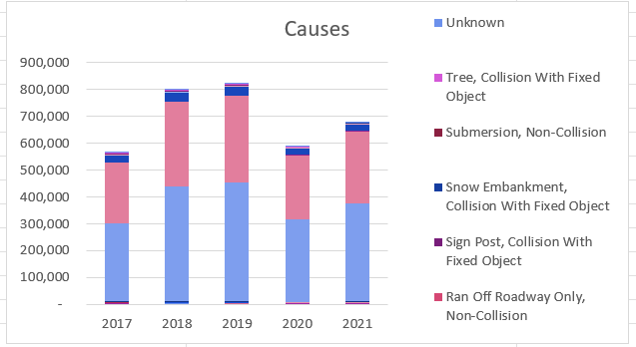

3. The vehicles involved in accidents have the registration of which state?

The pie chart shows that most vehicles getting into accidents are registered with New York state, with 89% as compared to that of the other state-registered vehicles.

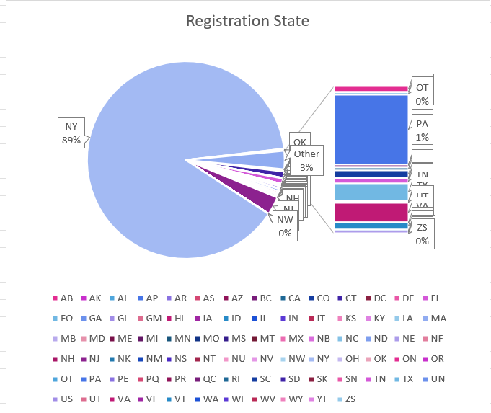

4. What is the action that has been performed prior to the accident of the motor vehicle?

Considering the rate of action recorded in the five years, Going Straight Ahead is the primary action observed, with 46.05% just before the accident.

Also, making a left turn on the red signal has the least rate of 0.02%

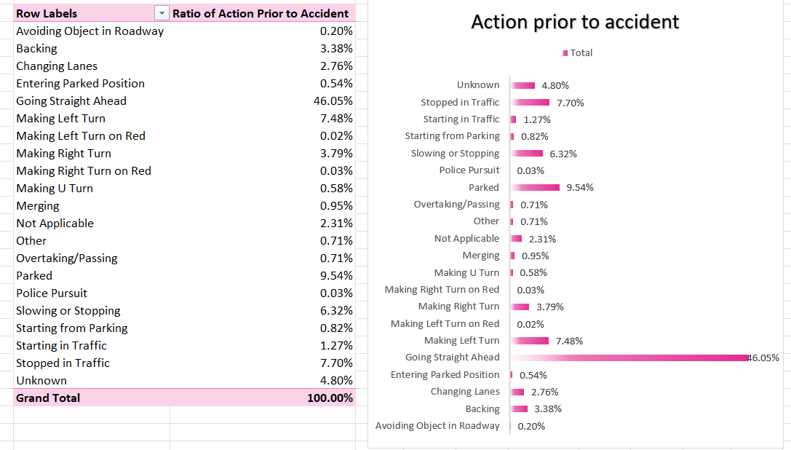

5. What are the top three vehicle body types reported for accidents in all years?

The top three vehicle body types reported for accidents in all years are

1. Suburban

2.4-door sedan

3. Pick-up truck

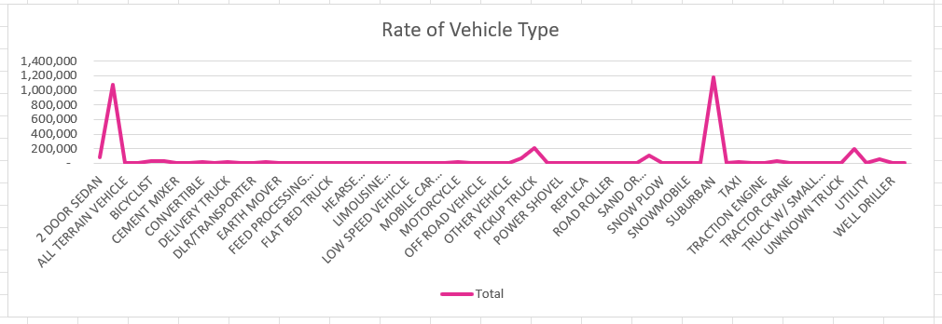

A few slicers are added to obtain more transparent and succinct facts about the dataset, including Fuel Type, Year, Contributing Factor 1, and Contributing Factor 2.



The accidents reported based on the factors and directions are also deduced using the stacked bar where Human is the leading contributing factor.

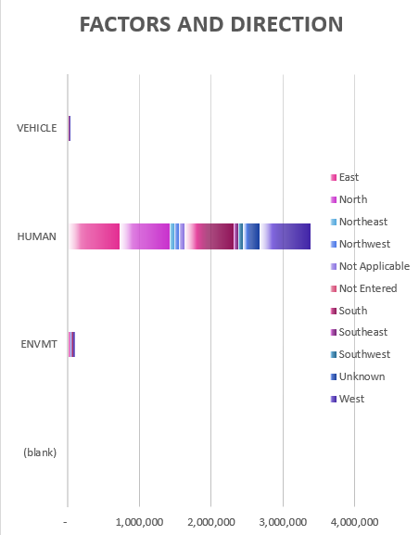

Observations/Assumptions:

From the data sets, it followed an upward curve from 2017 to 2019, but it took a downward slope in 2020 and 2021, and the reason I assume is that the COVID outbreak stopped people from going out. We can also get more detailed analysis based on the interactive dashboard where based on the fuel and year how many accidents happened that were reported.Also we can understand the analysis based on the factors and the different actions that are performed just prior to the accident.

To help prevent motor vehicle accidents in New York. One of the vital keys is checking the vehicle regularly to ensure it is in good working condition, taking a defensive driving course to improve one's skills, and being aware of the risks associated with driving in inclement weather.

As per analysis(*New York City Car Accident Statistics*, n.d.)On average, there were around 19,000 car accidents in New York City per month. Nevertheless, that is only an average. There are more accidents on some days and some months. The month with the most recorded accidents, according to the NYPD's crash data, is May (20,551), closely followed by June (20,479) and October (20,470). In 2018, February saw the fewest reported traffic collisions, with just 15,680 accidents.

Always obeying traffic laws is one of the essential precautions one can take to assist in preventing car accidents in New York. This entails respecting speed restrictions, traffic signals, and signs and staying focused while driving. Additionally, it is crucial to ensure everyone in your car is correctly buckled up and always use your seatbelt.

Another crucial aspect is to keep your eyes and ears open when driving. This entails being alert to other road users and any situations that can affect how you drive. Given that these regions can be highly hazardous to vehicles, it is crucial to be informed of any possible construction or roadwork.

Strengthened education and public awareness initiatives, as well as stringent regulations and penalties for these activities, to address these problems is one of the solutions.

**Citations:**

*New York City Car Accident Statistics*. (n.d.). Mirman, Markovits & Landau, P.C. Retrieved February 9, 2023, from https://mirmanlawyers.com/new-york-car-accident-lawyer/statistics/

Potoski, L. (2018, May 21). *Crash (accident) reports* [Text]. New York DMV. https://dmv.ny.gov/dmv-records/crash-accident-reports